**EXPERIMENT NO –04:**

**AIM::**

**Data Link Layer Traffic Simulation using Packet Tracer Analysis of ARP**

**REQUIRMENTS::**

**Cisco packet tracer,hubs,switches.**

**PROCEDURE::**

**1.open the cisco tracer and drag the hub to the topology site.**

**2.then drag an two pc’s also on to the site .**

**3.server is also dragged to the work space.**

**4.now arrange them and establish the connections among them as shown below.**

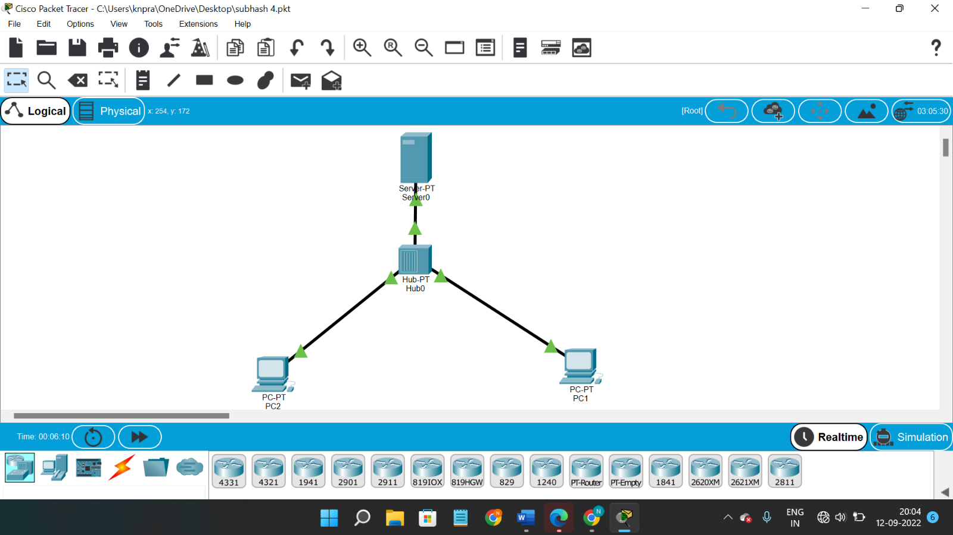

**5.then try to give them the ip address .**

**6.After giving the ip address ,you will find the msg symbol on the top of working space.select it and place on one pc,the select an other pc where you want to send data.**

**7.then start stimulation then you will be able to find the path of transmission of packet.as bellow.**

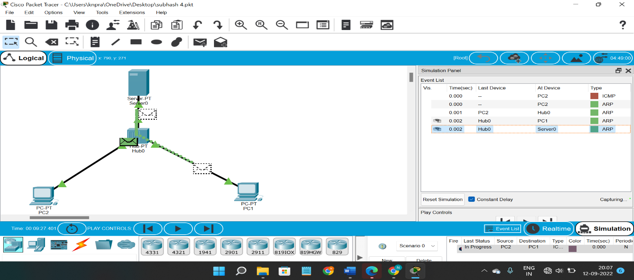

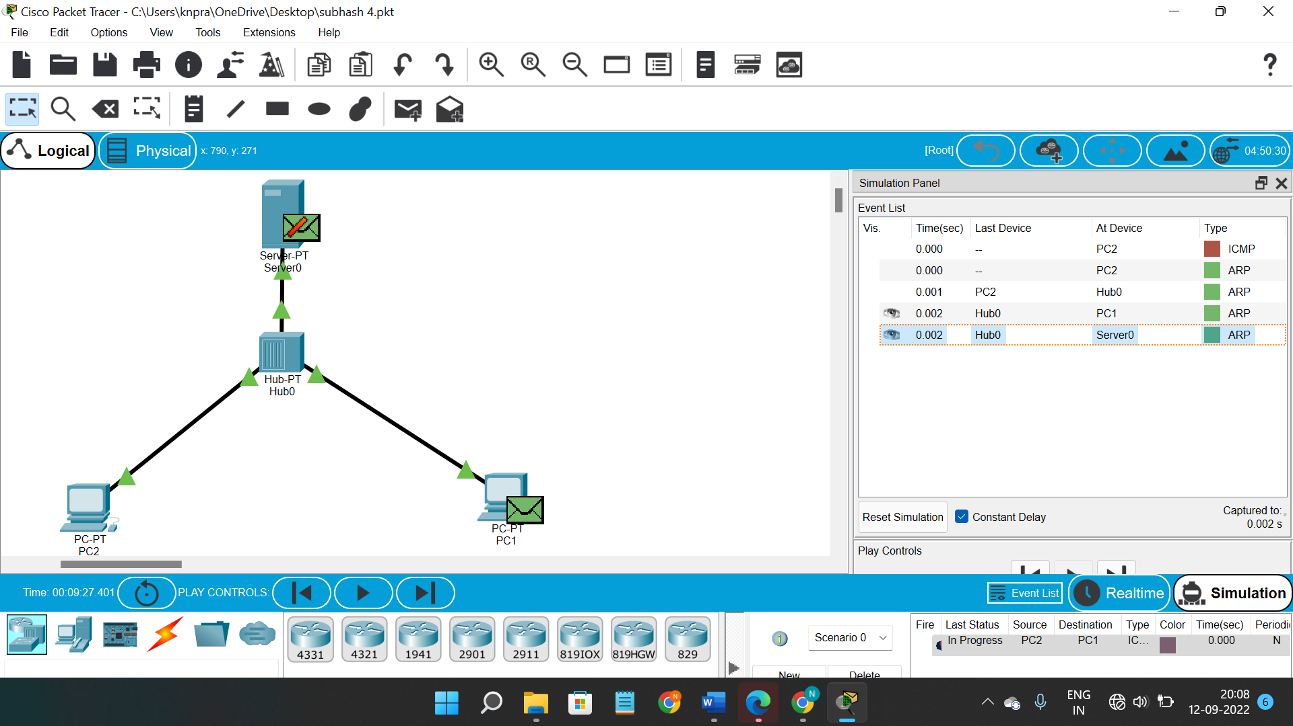

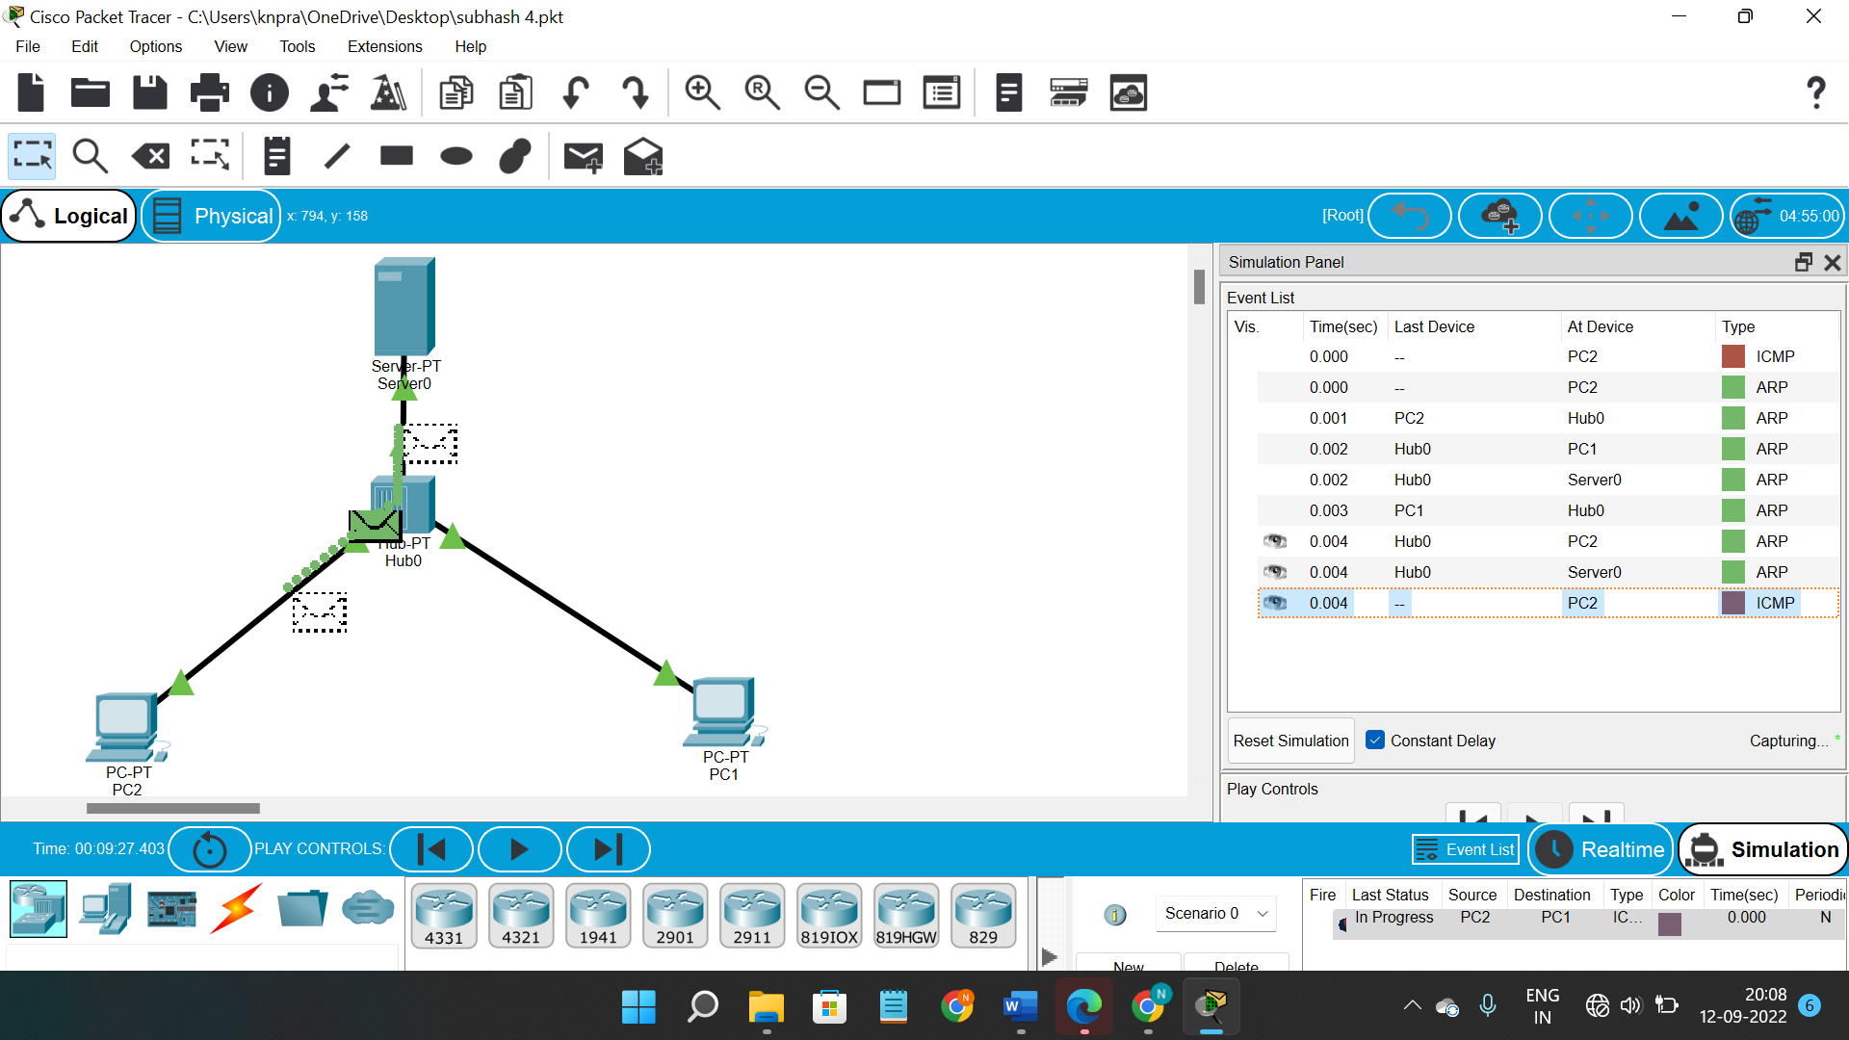

**Result ::**

**So finnaly if you look at the result the msg will be transferred clearly.**